**P3 - Identify emerging network technologies**

**Introduction**

In this assignment, I will be identifying key aspects of emerging network technologies. I will be naming video on demand (VoD), server virtualisation, and Wi-Fi (this is relatively new).

**Video on demand (VoD)**

Video demand are systems that allow any user to listen to music/audio. This has developed very popular and more people listen to music portably. They can use it on the bus, anywhere they go; they can listen to music/audio. For example, if I had an audio about my exam, I can go to another place whilst listening to the audio about my exam.

**FIVE ASPECTS**

|  |  |
| --- | --- |
| GOOD | BAD |
| * Portable – you can listen to the content whenever you want on any device | * Having loud music can have an effect on the user’s ears |
| * The user can use headphones so they only can hear the music/audio | * Expensive to purchase the system |
| * Entertaining | * Disturbs others without using headphones |
| * Pause, rewind and forward the content whenever the user feels like it | * Without Internet, the user cannot use VOD |
| * Free e.g. BBC IPlayer | * Depends on which system the user is listening/watching the content e.g. Netflix, you have to pay monthly. |

**EXAMPLES**

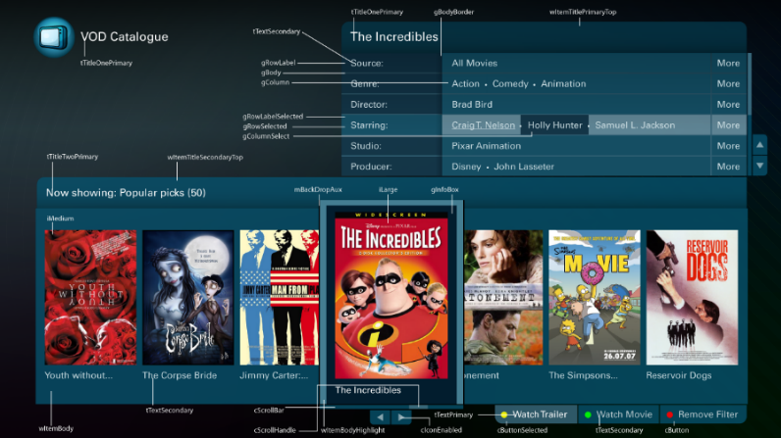[](http://en.wikipedia.org/wiki/File:Freesat_iPlayer_home.jpg)**BBC IPlayer, 4oD, ITV Player, Netflix, 5 on Demand**

**Wi-Fi**

Wi-Fi is used everywhere. This is a network that allows users to gain access to the internet by putting a unique password to gain access. The password is usually changed the by frequent user, but some let it be and it is usually at the back of a router. It could be a phrase or numbers. Wi-Fi is usually used at any organisation. Wi-Fi can be set up anywhere from homes to office to schools. It can be anywhere.

**Server Virtualisation**

Server virtualisation is the servers that make the resources. The resources could be a number of devices to make what is needed of a server e.g. processor; operating system and any sort of thing that makes up an server. Private servers can be made my inviting guests by an administrator. For example, in Minecraft, you can make private servers to play with each other live. Private servers are created by an admin and controlled by an admin.